|  |  |
| --- | --- |
| **Programming II**  Diploma in IT / DS / CSF  Year 1 (2021/22) Semester 2 | Week 8 |
| 2 hours |
| **Practical 8 Class Associations (Part 1)** | |

**Objectives**

At the end of this practical, the students should be able to:

* implement Class associations

|  |
| --- |
| **IMPORTANT**   * Create a folder, **week08.** * Create a new Console App (.NET Core) project, **Snnnnnnnn_ShippingApp**, in the **Week08** folder created above *(note:* ***Snnnnnnnn*** *is your Student Number)*. * At the end of the session, copy the folder **Week08** folder (which contains all your work) to PRG2 network folder: **\\ictspace.ict.np.edu.sg\PRG2**. |

1. Based on the Class diagram given below, implement the following classes:
   1. ShippingAddr class
   2. Customer class

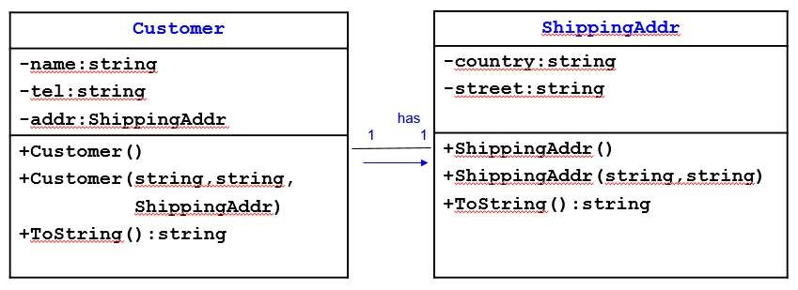

1. In the *Program.cs* file, do the following:
2. Create a List, **customerList**, to store **Customer** objects.
3. Write an **InitCustomerList(customerList)** method to create 3 **Customer** objects with the information given below and add them into **customerList**.

|  |  |  |  |
| --- | --- | --- | --- |
| Name: Tel: Country: Street: | John Tan  98501111  Singapore Clementi Rd | Amy Lim  99991111  Hong Kong Mong Kok Rd | Tony Tay  91112222  Malaysia Malacca Rd |

1. Call the **InitCustomerList(customerList)** method in the **Main()** method.
2. Write a **ListCustomers(customerList)** method to display the details of all customers as shown below.

|  |
| --- |
| Name Tel Country Street  John Tan 98501111 Singapore Clementi Road  Amy Lim 99991111 Hong Kong Mong Kok Road  Tony Tay 91112222 Malaysia Malacca Road |

1. Call the **ListCustomers(customerList)** method in *Main()* method.

**Plagiarism Warning:**

**If a student is found to have submitted work not done by him/her, he/she will not be awarded any marks for this practical. Disciplinary action may also be taken.**

**Similar action will be taken for student who allows other student(s) to copy his/her work.**